Computer Networks Lab (CS302)

Report Submission: CN Assignment Lab-5

Group Member Details:

1.Mahadev M Hatti 191CS133

2.Darshan A V 191CS219

1. Develop a code to illustrate a secure socket connection between client and server

2. Capture TCP Packets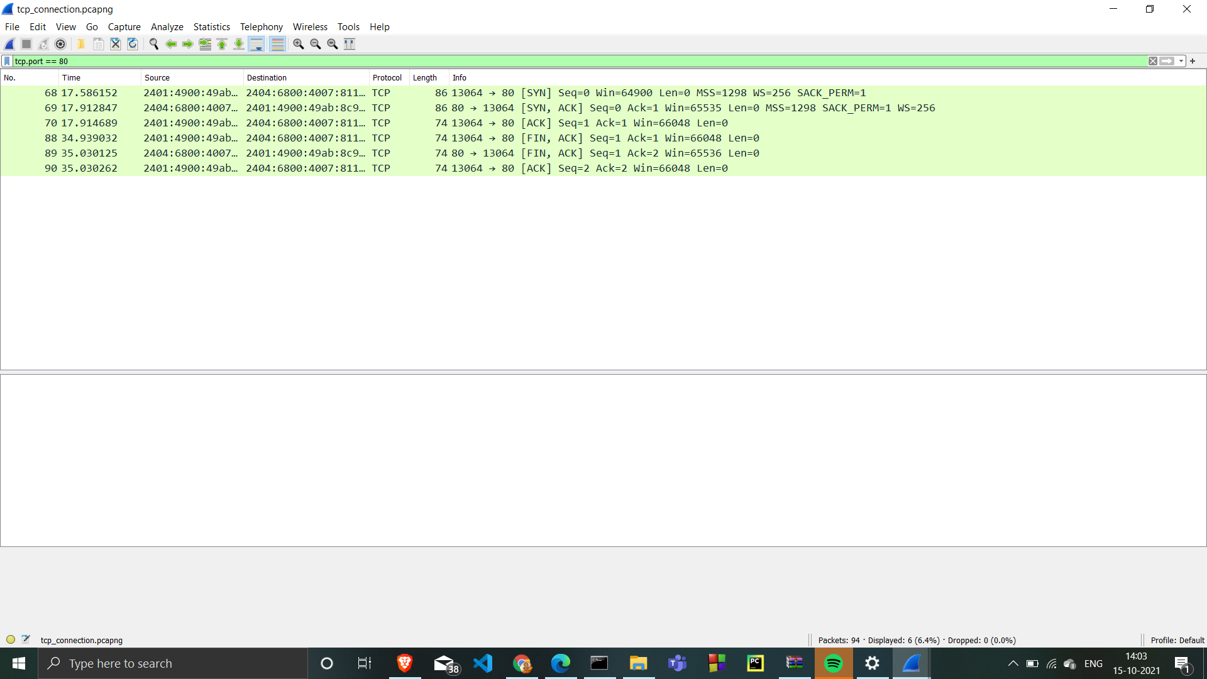

1. [Started the a Wireshark capture](https://en.wikiversity.org/wiki/Wireshark/Start).
2. [Open a command prompt](https://en.wikiversity.org/wiki/Command_Prompt/Open).
3. Type **telnet www.google.com 80** and press **Enter**.
4. Close the command prompt to close the TCP connection.
5. [Stop the Wireshark capture](https://en.wikiversity.org/wiki/Wireshark/Stop).

a. Analyse the three-way handshake during the establishment of the communication

Selectect the first TCP packet, labelled **http [SYN]**

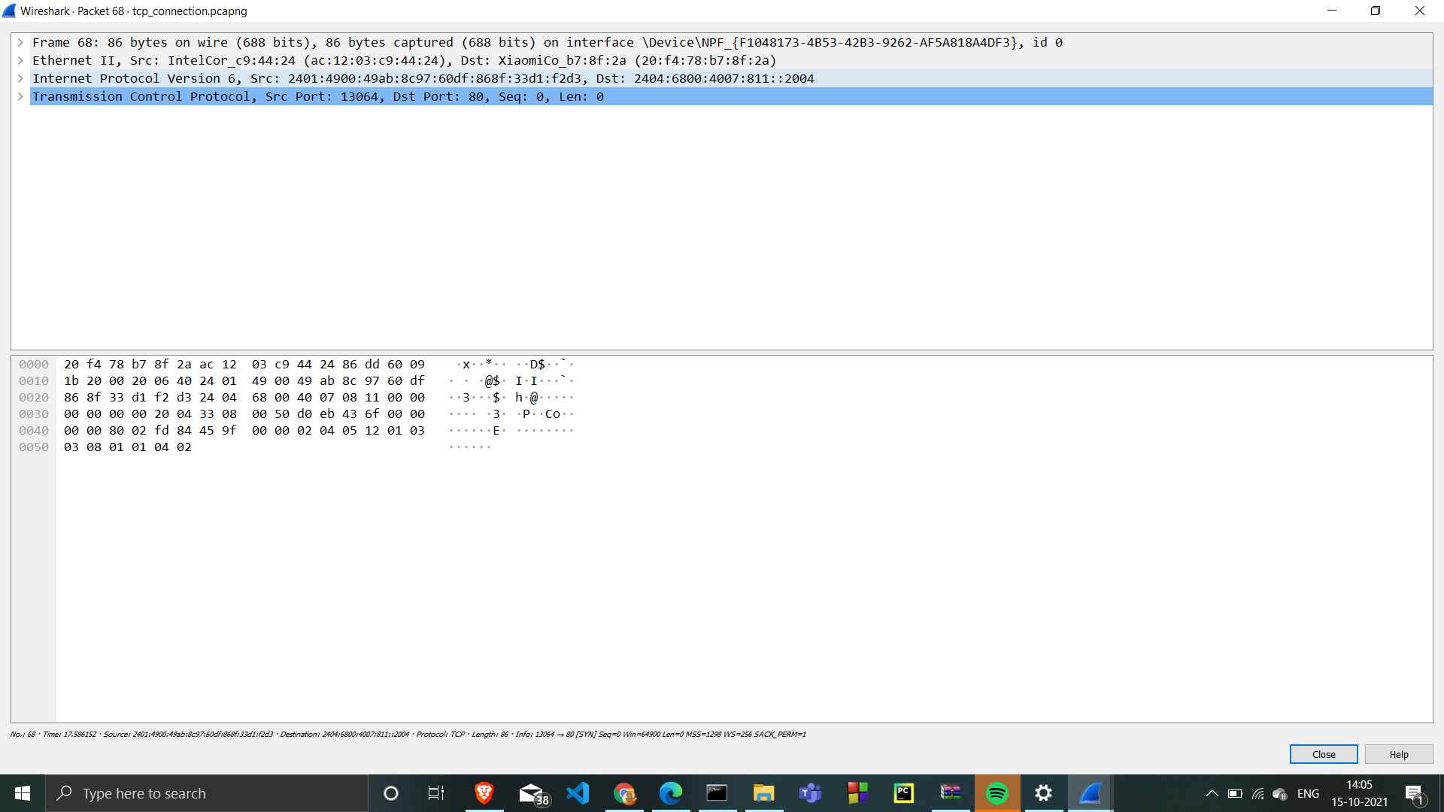

it is an Ethernet II / Internet Protocol Version 4 / Transmission Control Protocol frame.

Expand Ethernet II

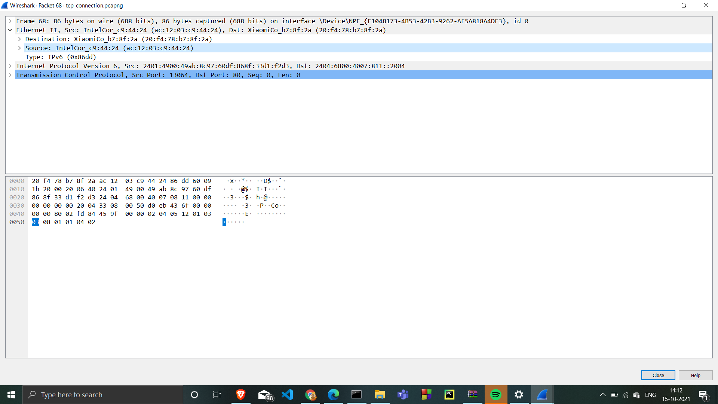

The destination is default gateway's MAC address

the source should be your MAC address

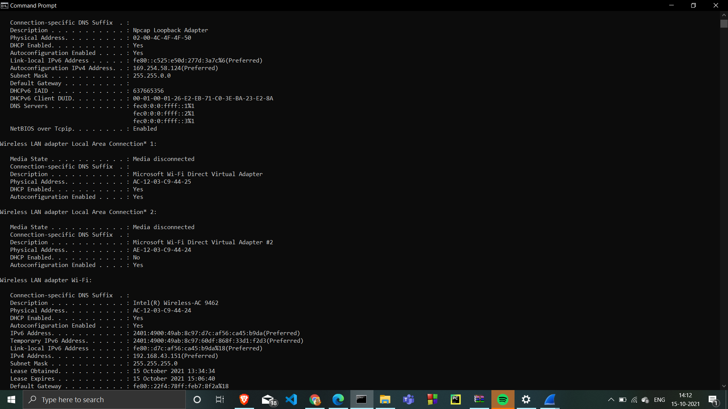

Expand Internet Protocol Version 4 to view IP details

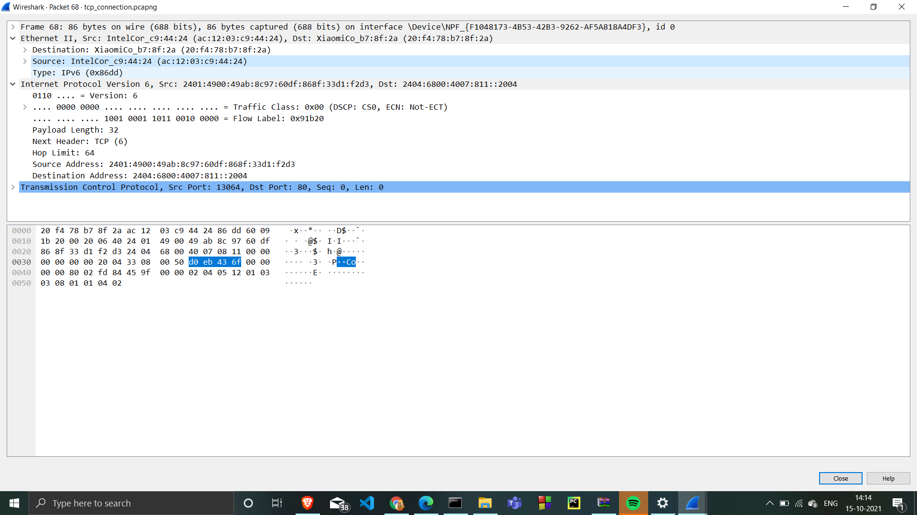

the source address is system IP address.

2401:4900:49ab:8c97:d7c:af56:ca45:b9da

destination address is the IP address of one of Google's web servers.

Expand Transmission Control Protoco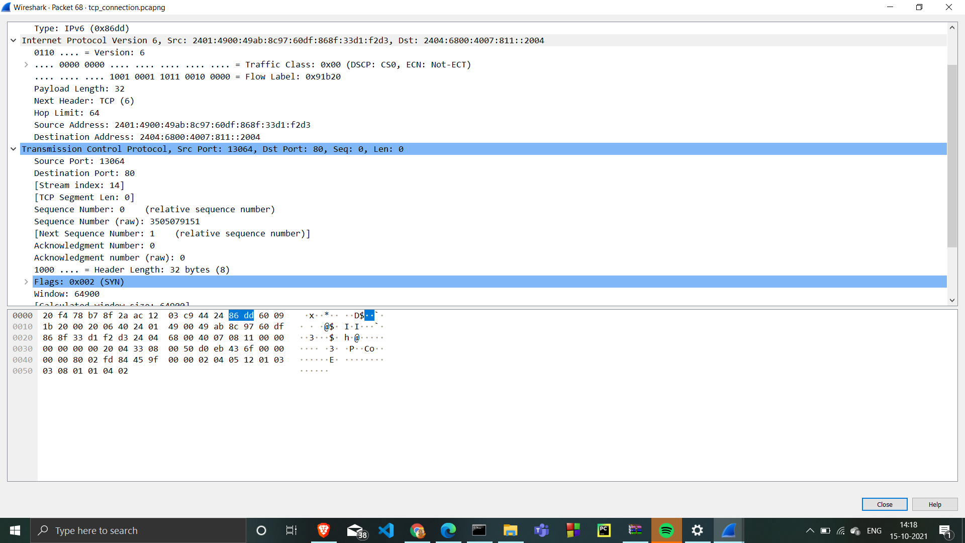

Source port is a dynamic port selected for this connection.

Destination port. Notice that it is http 80

Sequence number is 0

Expand Flags 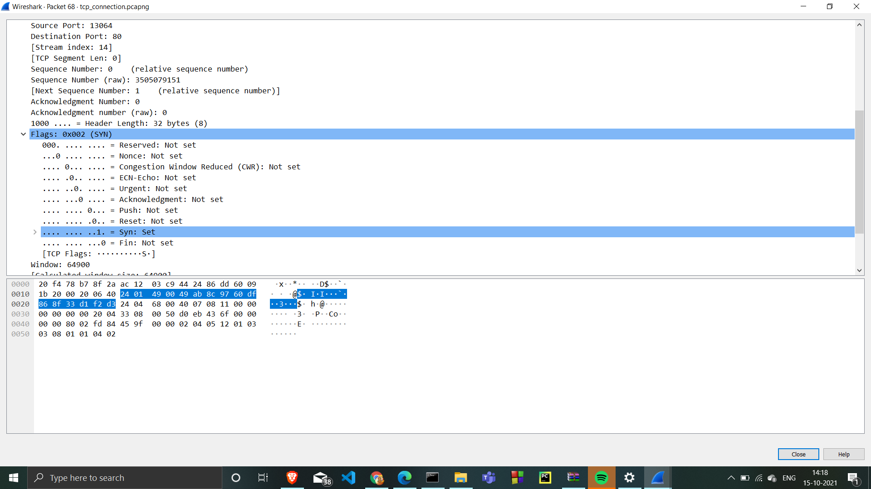

SYN is set ,indicating first segment in the TCP three-way handshake.

Analyse TCP SYN, ACK Traffic

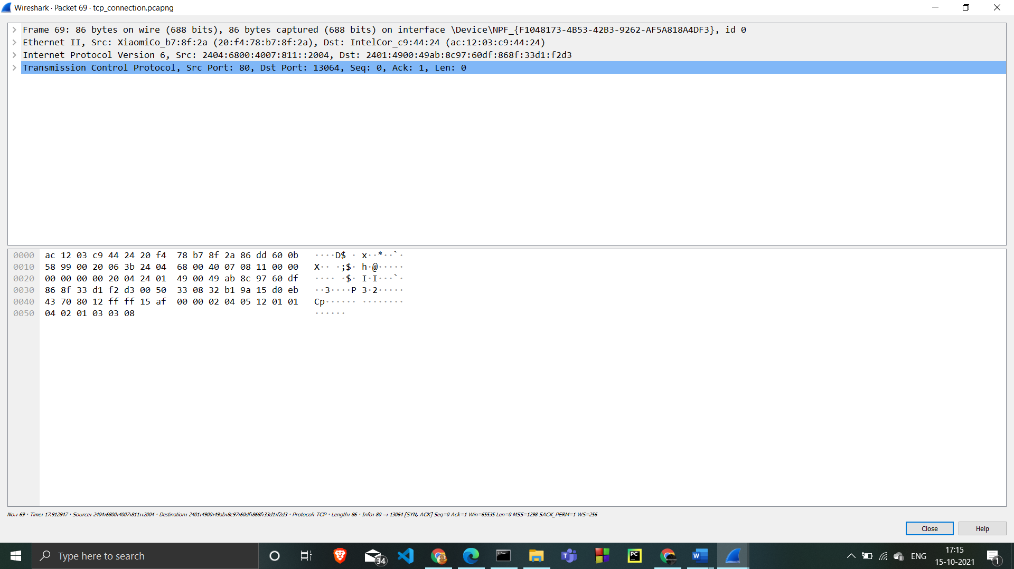

it is an Ethernet II / Internet Protocol Version 4 / Transmission Control Protocol frame.

Expand Ethernet II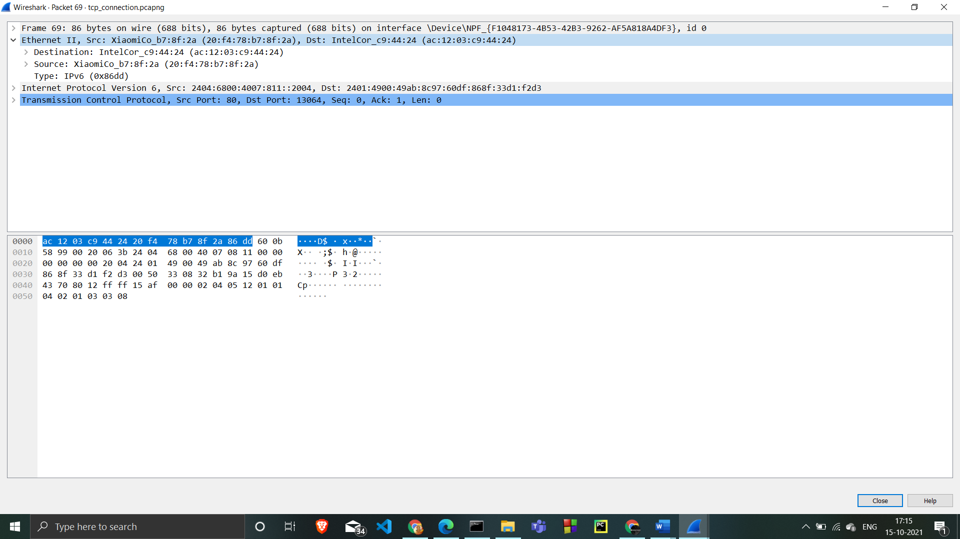

The destination is MAC address

 The source is default gateway MAC address

Expand Internet Protocol Version 4

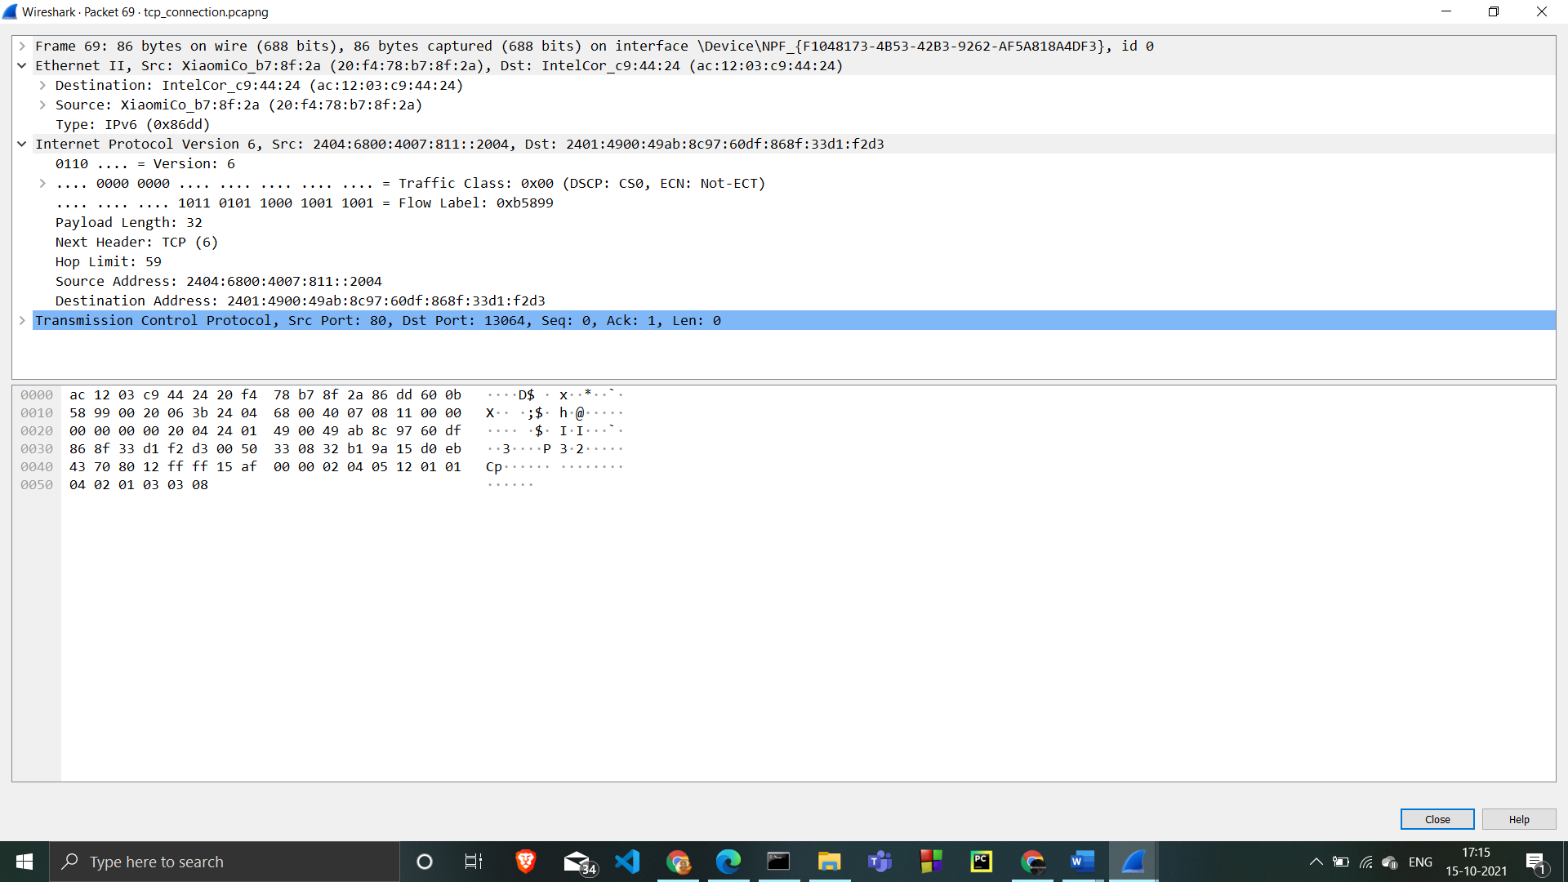

the source address is the Google web server IP address

the destination address is system IP address.

Expand Transmission Control Protocol

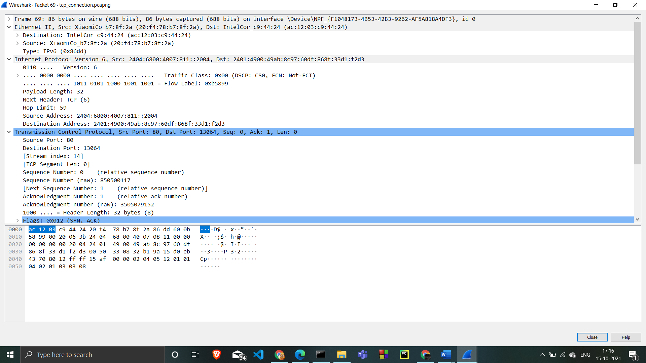

the Source port is http (80)

Destination port is the same dynamic port selected for this connection.

Sequence number is 0, Acknowledgement number is 1

Expand Flags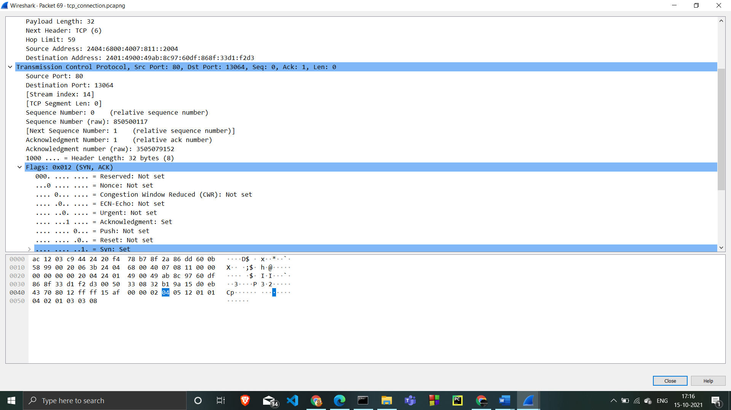

SYN and ACK are set

 indicating the second segment in the TCP three-way handshake.

Analysing TCP ACK Traffic

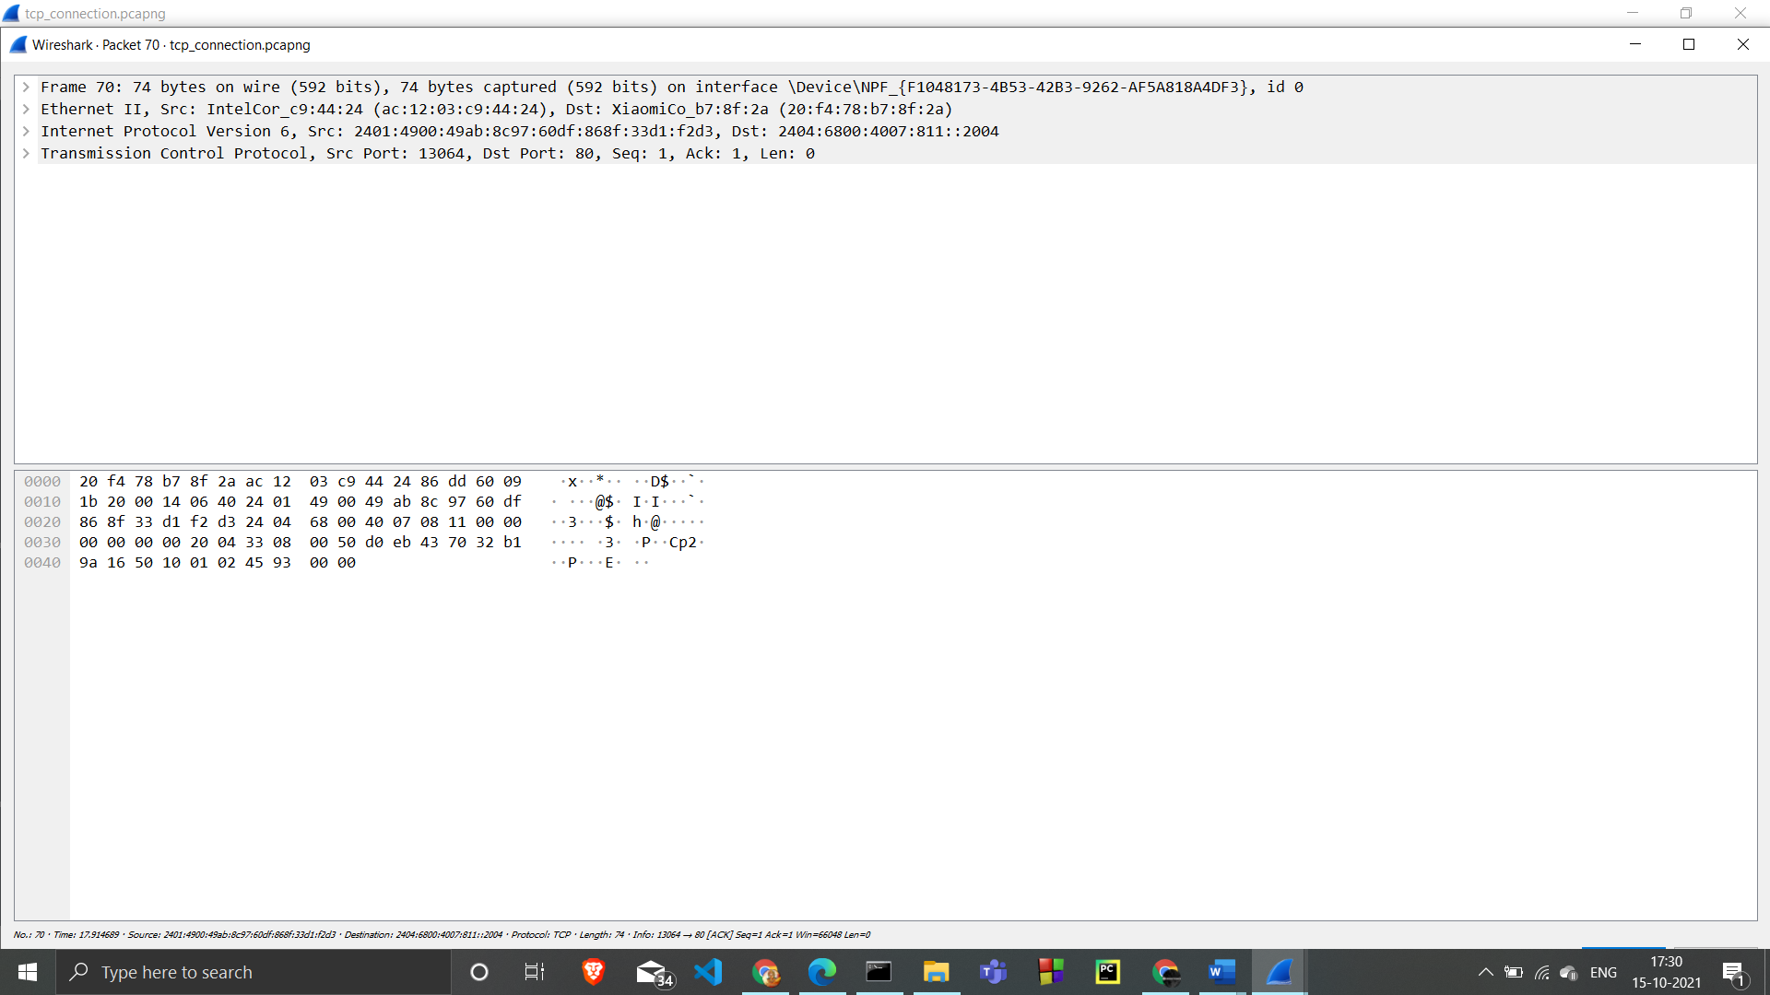

it is an Ethernet II / Internet Protocol Version 4 / Transmission Control Protocol frame.

Expand Ethernet II

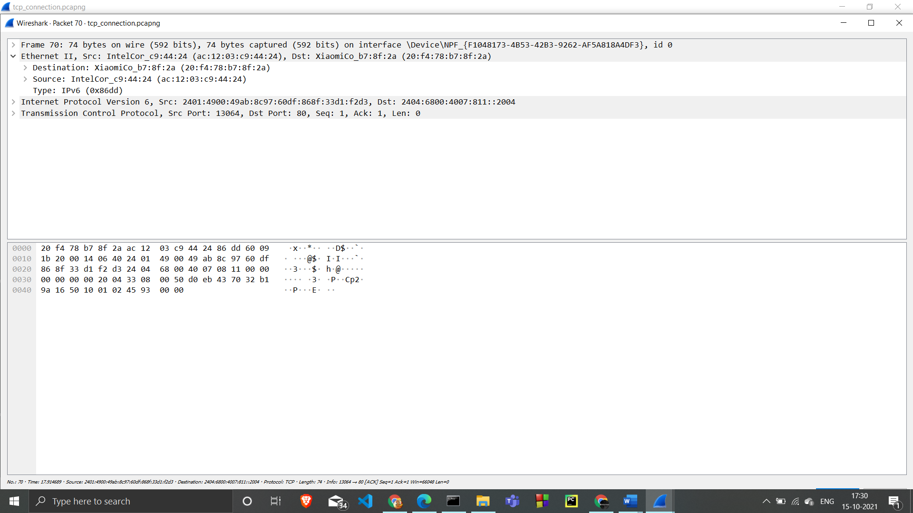  the source address is systeam IP address.

 the destination address is the Google web server IP address.

Expand Internet Protocol Version 6

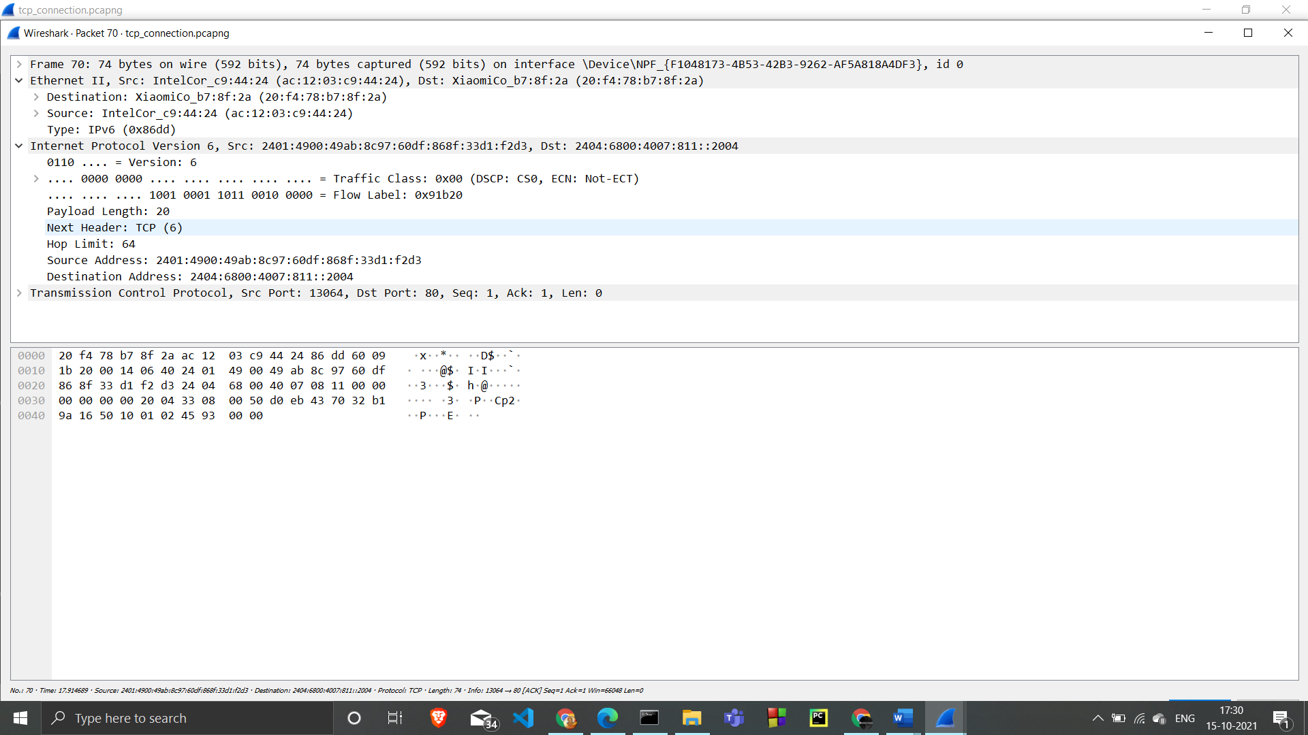

the source address is IP address.

the destination address is the Google web server IP address.

Expand Transmission Control Protocol

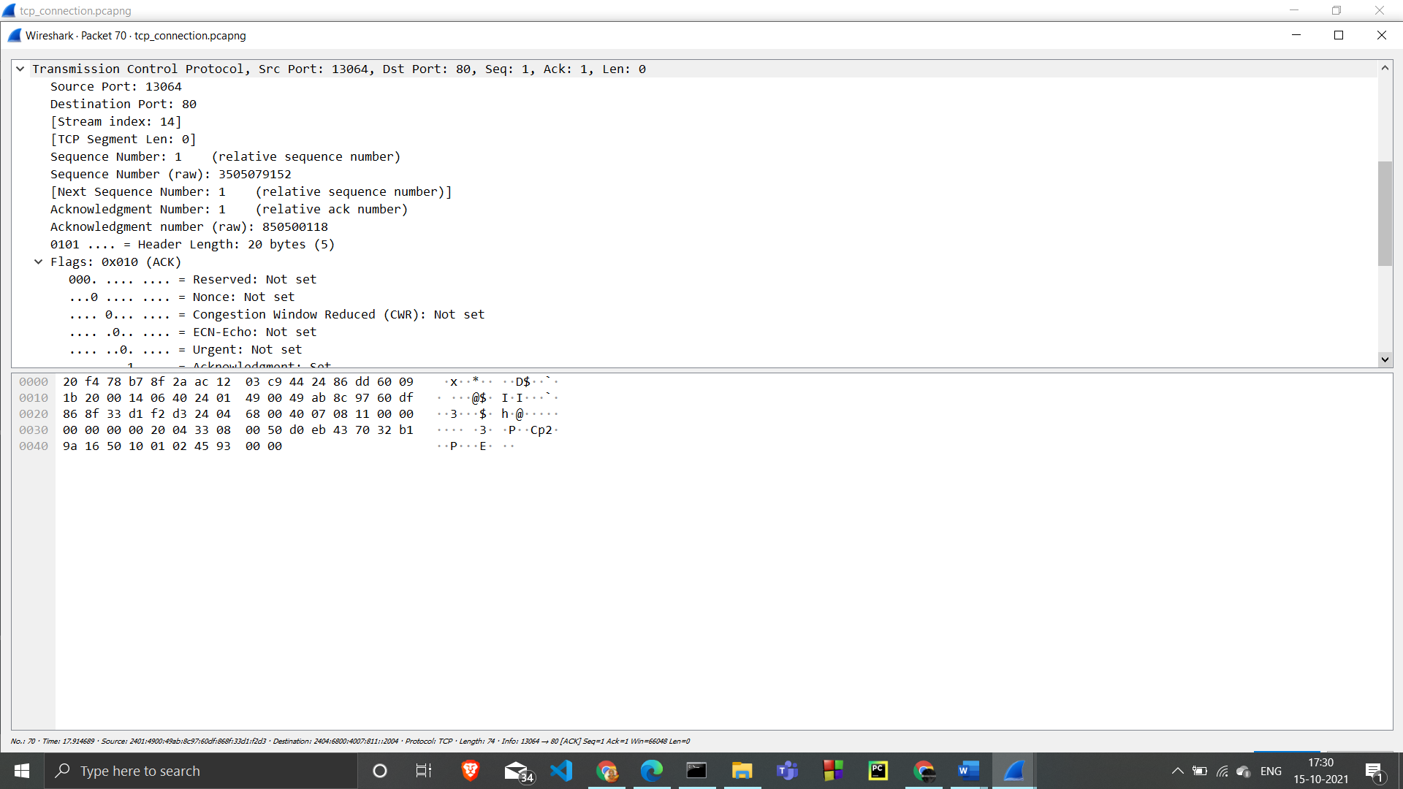

Source port is the same dynamic port selected for this connection

Destination port is http (80)

Sequence number is 1 ,  Acknowledgement number is 1

Expand Flags

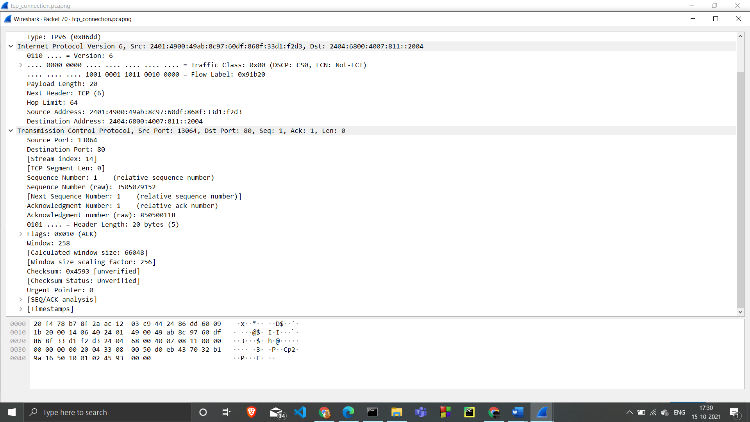

ACK is set, indicating the third segment in the TCP three-way handshake.

client has established a TCP connection with the server.

Analyse TCP FIN ACK Traffic

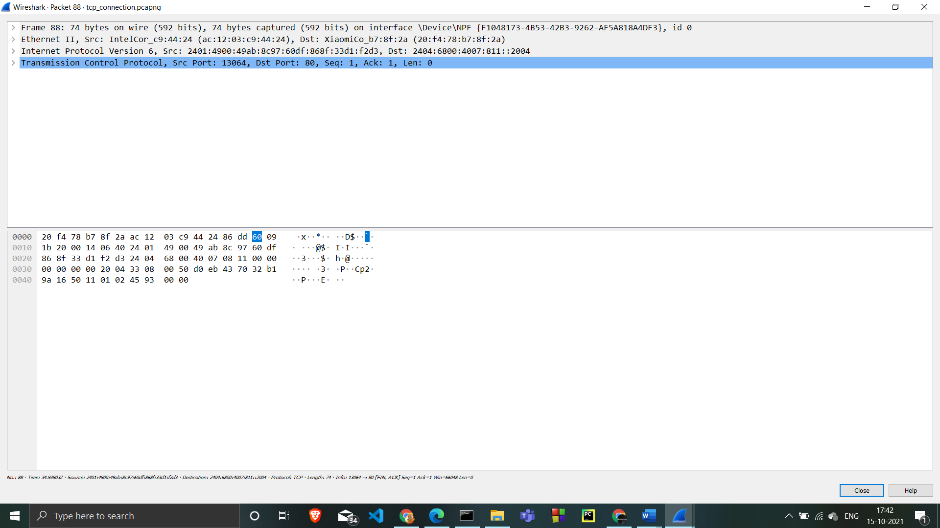

is an Ethernet II / Internet Protocol Version 4 / Transmission Control Protocol frame

Expand Ethernet II

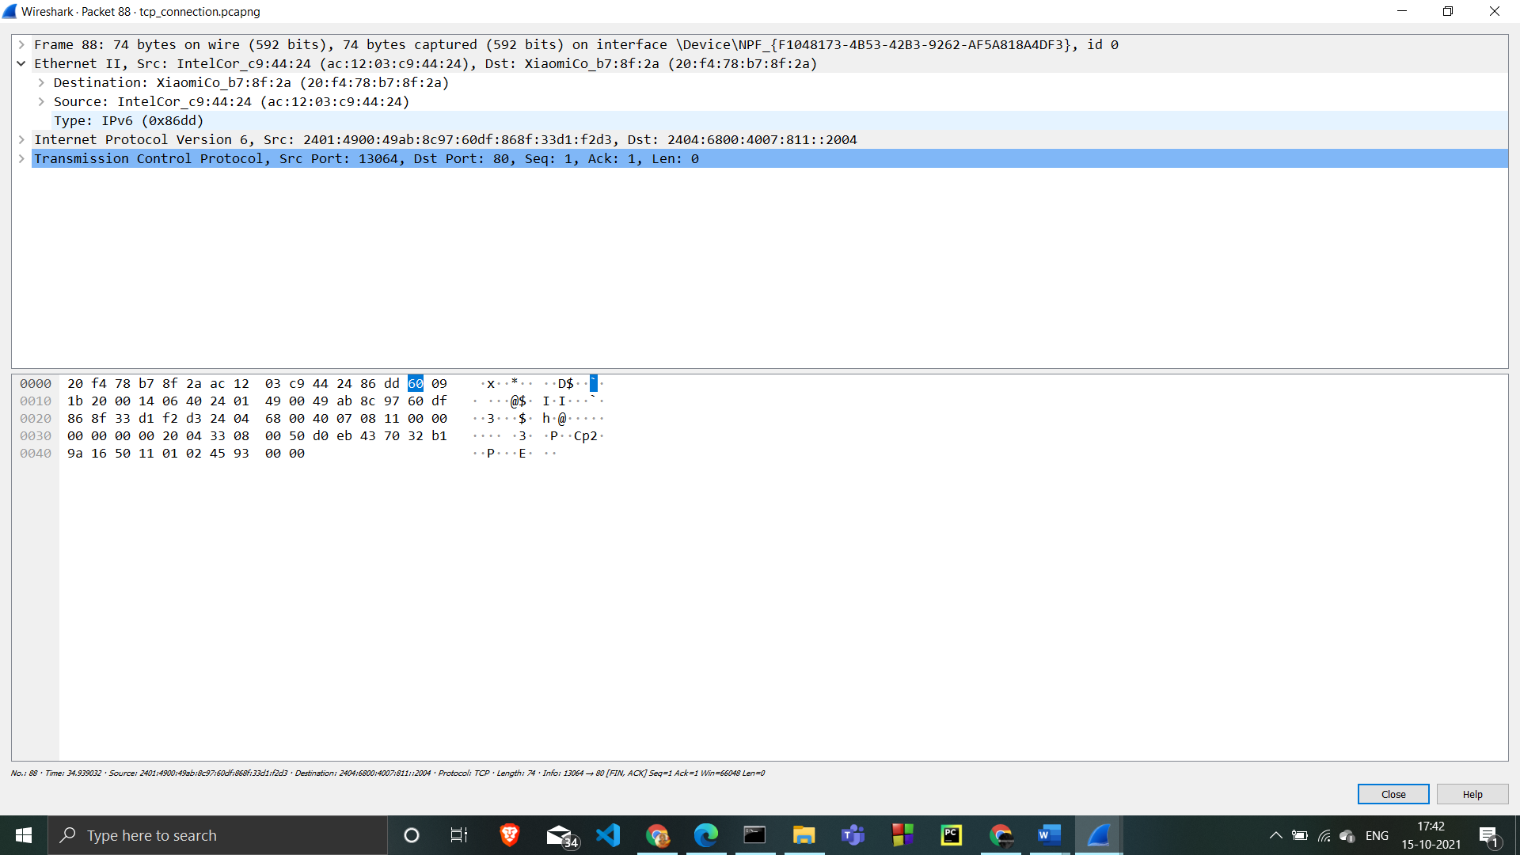

The destination is default gateway MAC address

the source is MAC address

Expand Internet Protocol Version 4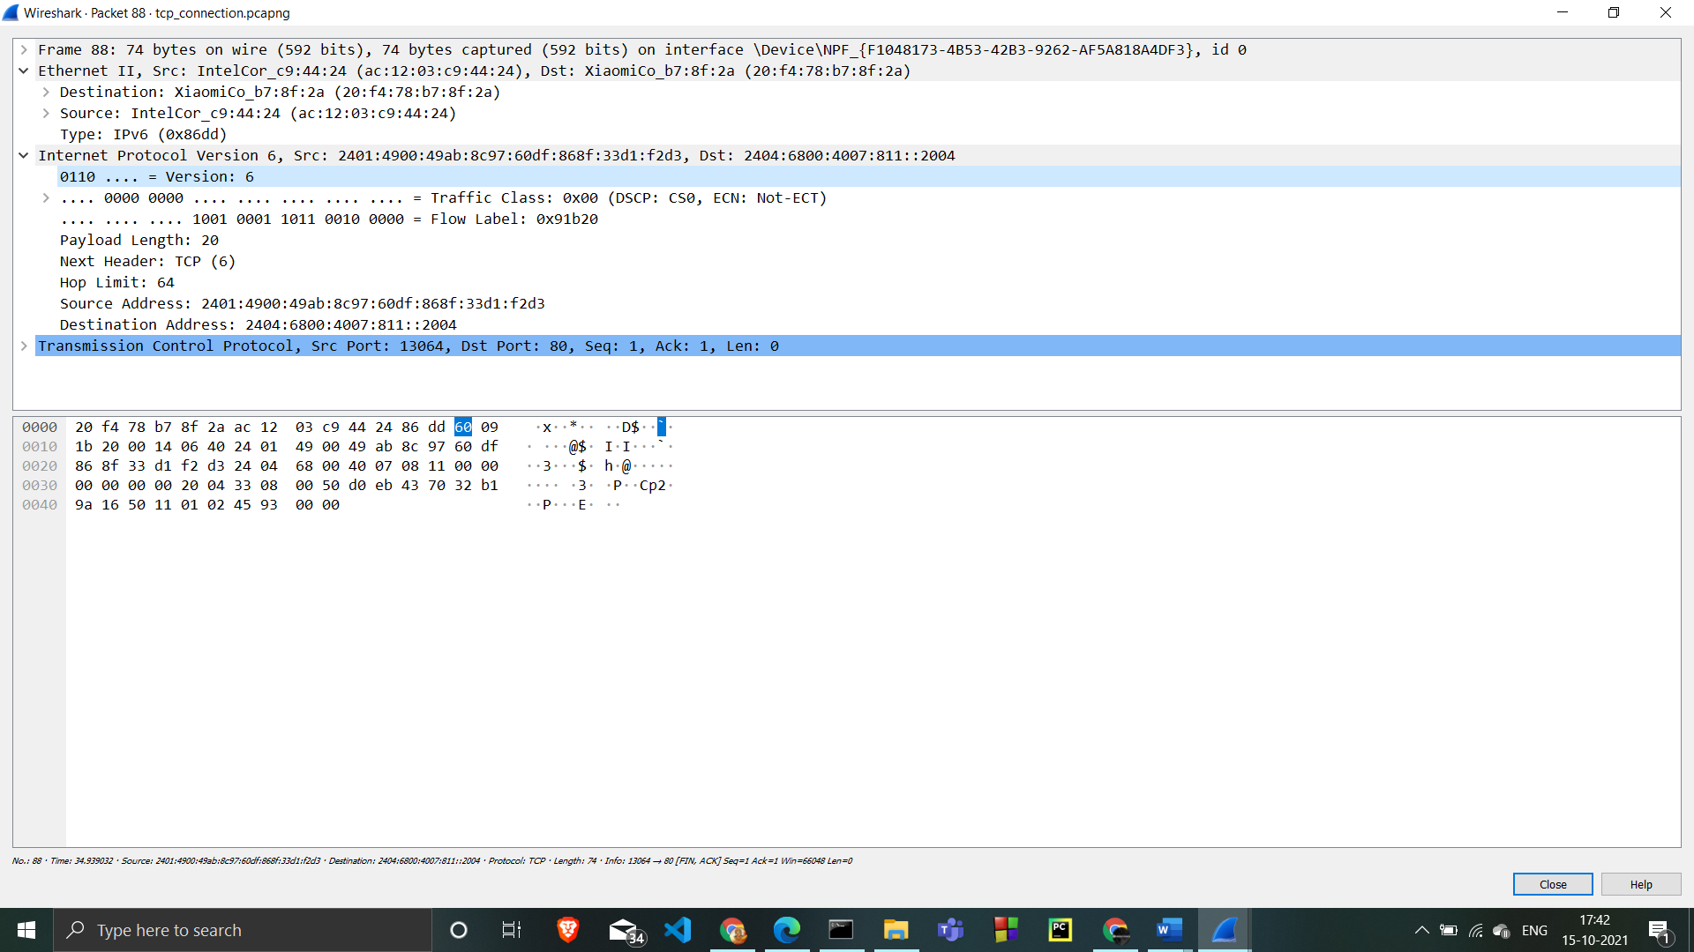

The source address is systeam IP address.

the destination address is the Google web server IP address.

Expand Transmission Control Protocol

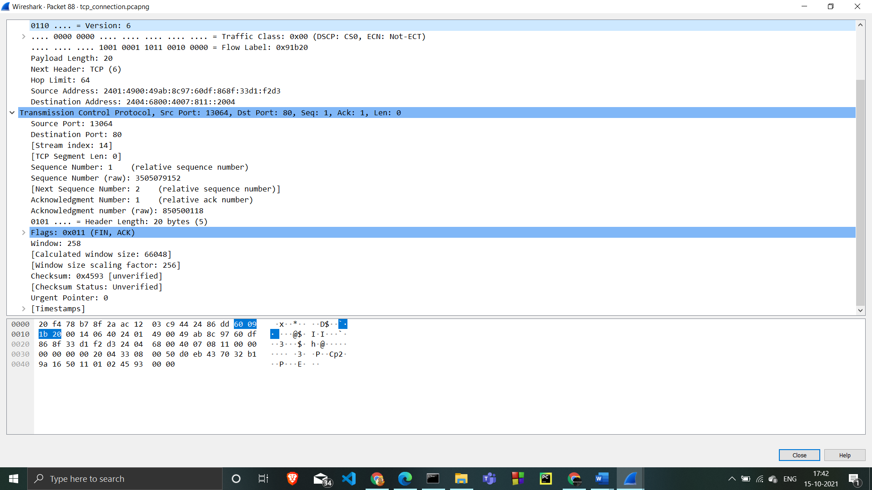

Source port is dynamic port selected for this connection.

the Destination is http (80).

Sequence number is 1, Acknowledgement number is 1

Expand Flags

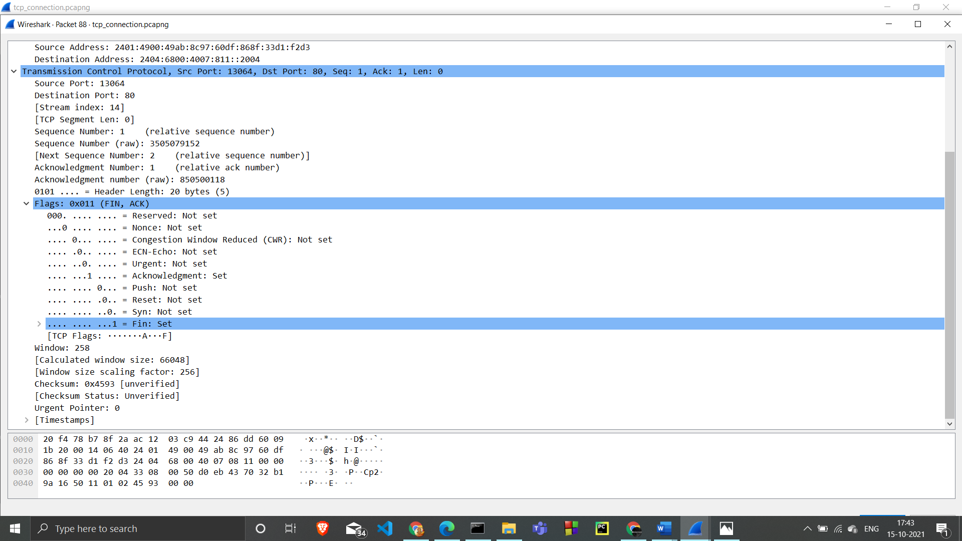

FIN and ACK are set

 indicating the first segment in the TCP teardown handshake .

The client has indicated it is closing the TCP connection with the

Analyse TCP FIN ACK Traffic

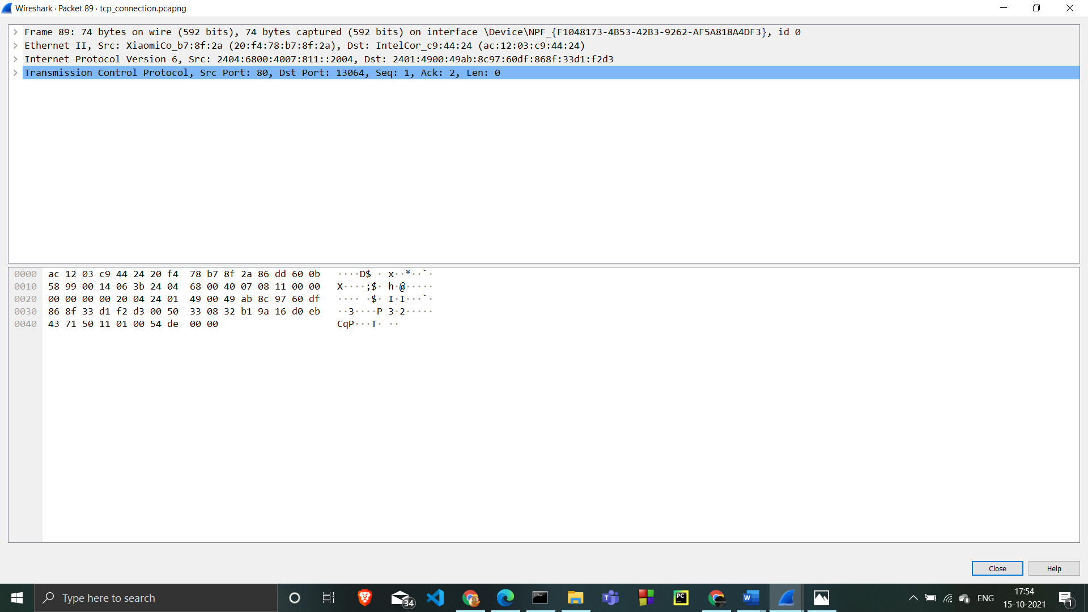

is an Ethernet II / Internet Protocol Version 4 / Transmission Control Protocol frame.

Expand Ethernet II to view Ethernet details

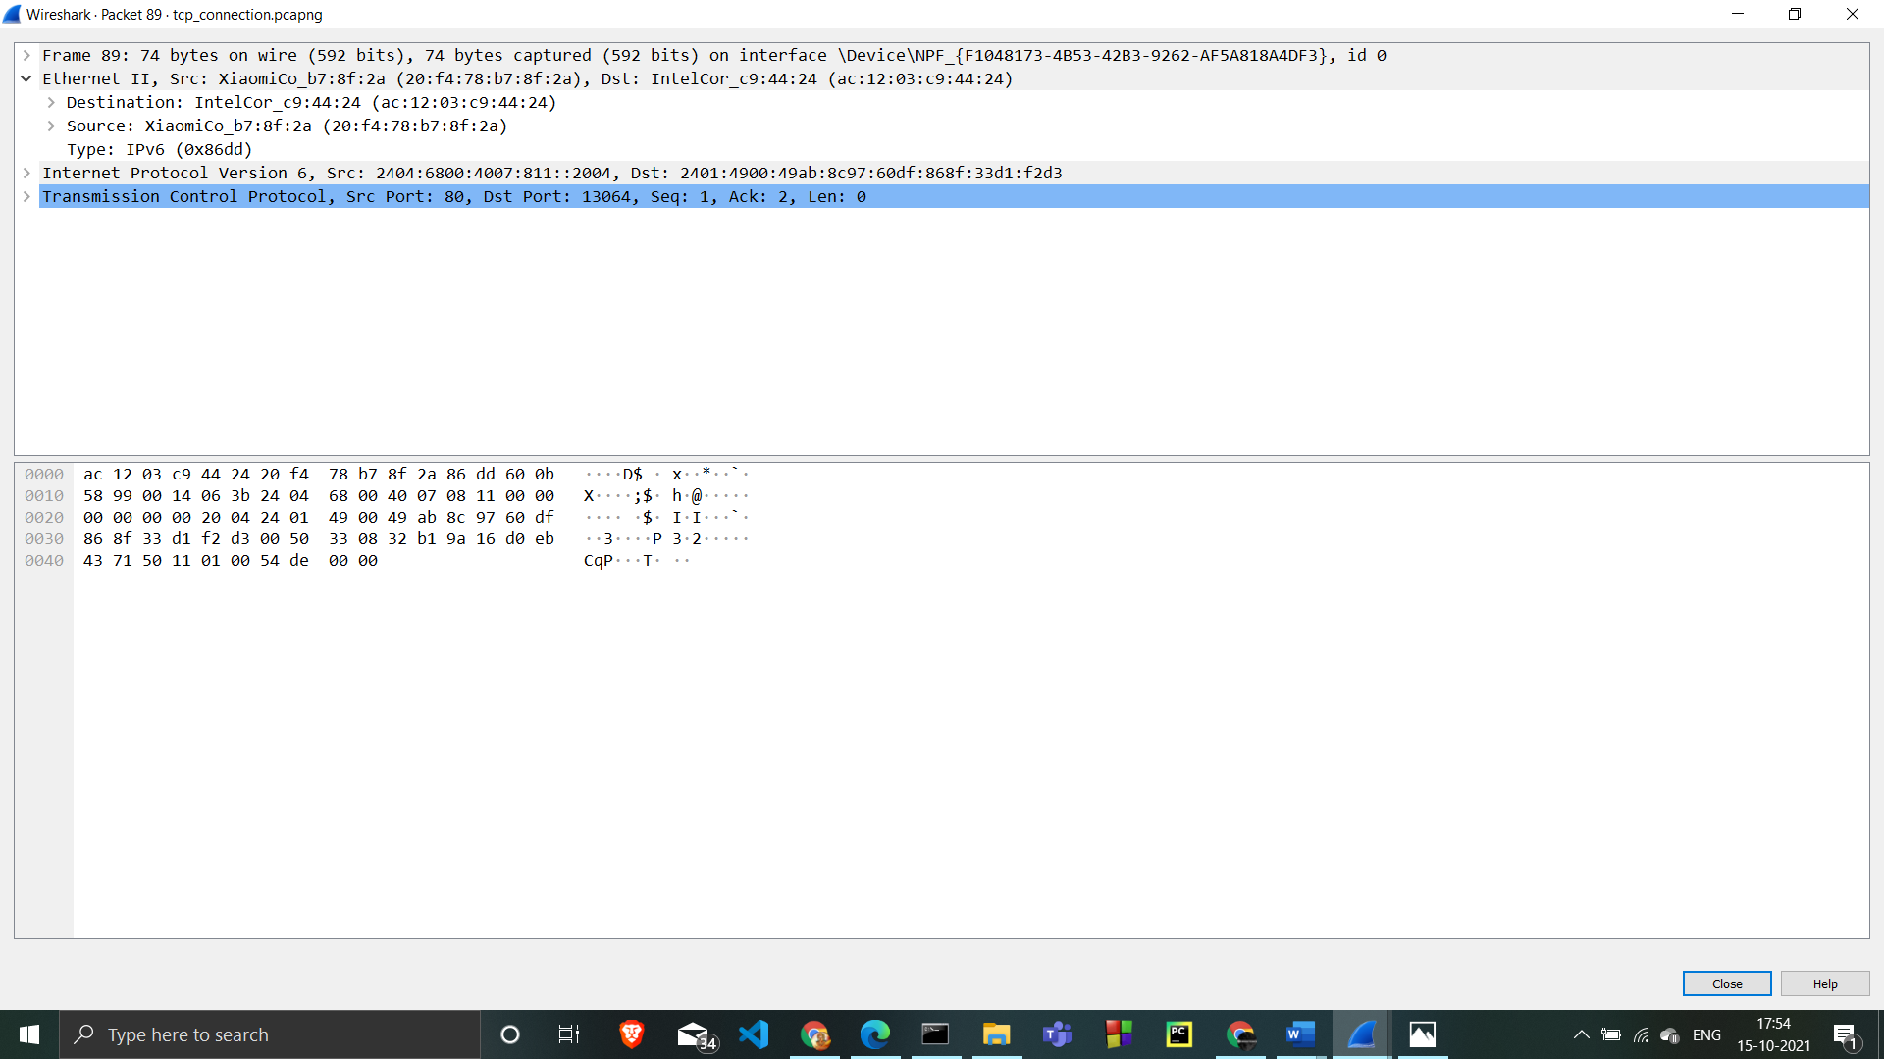

The destination system MAC address

the source should be system default gateway MAC address

Expand Internet Protocol Version 4

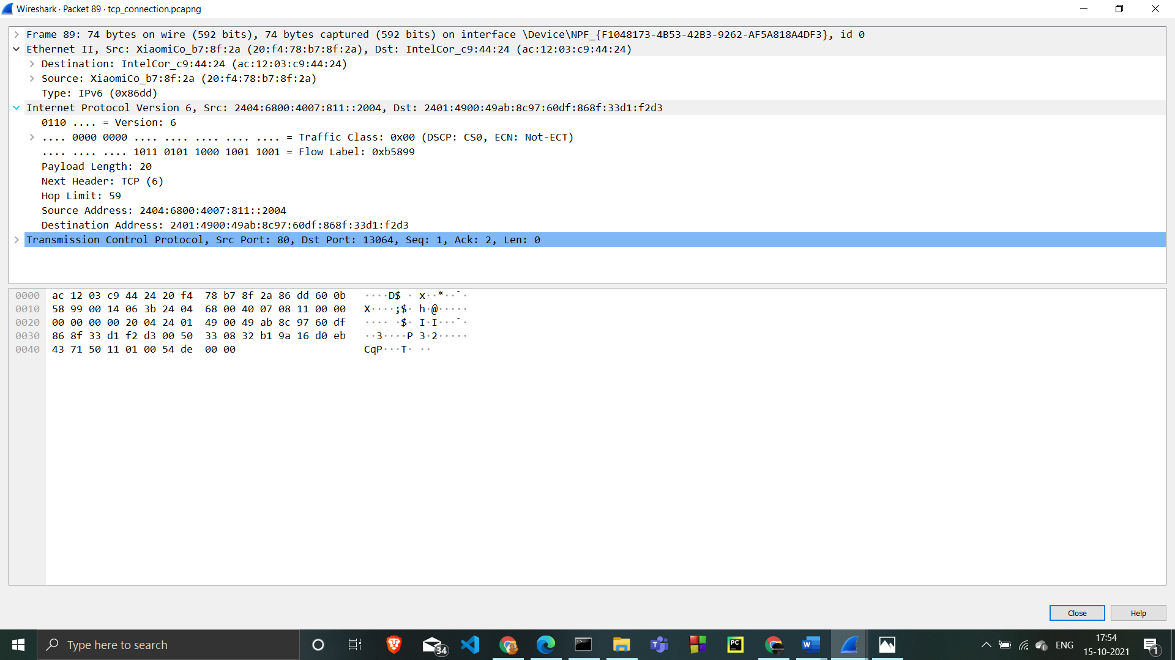

the source address is the Google web server IP address

the destination address is system IP address

Expand Transmission Control Protocol

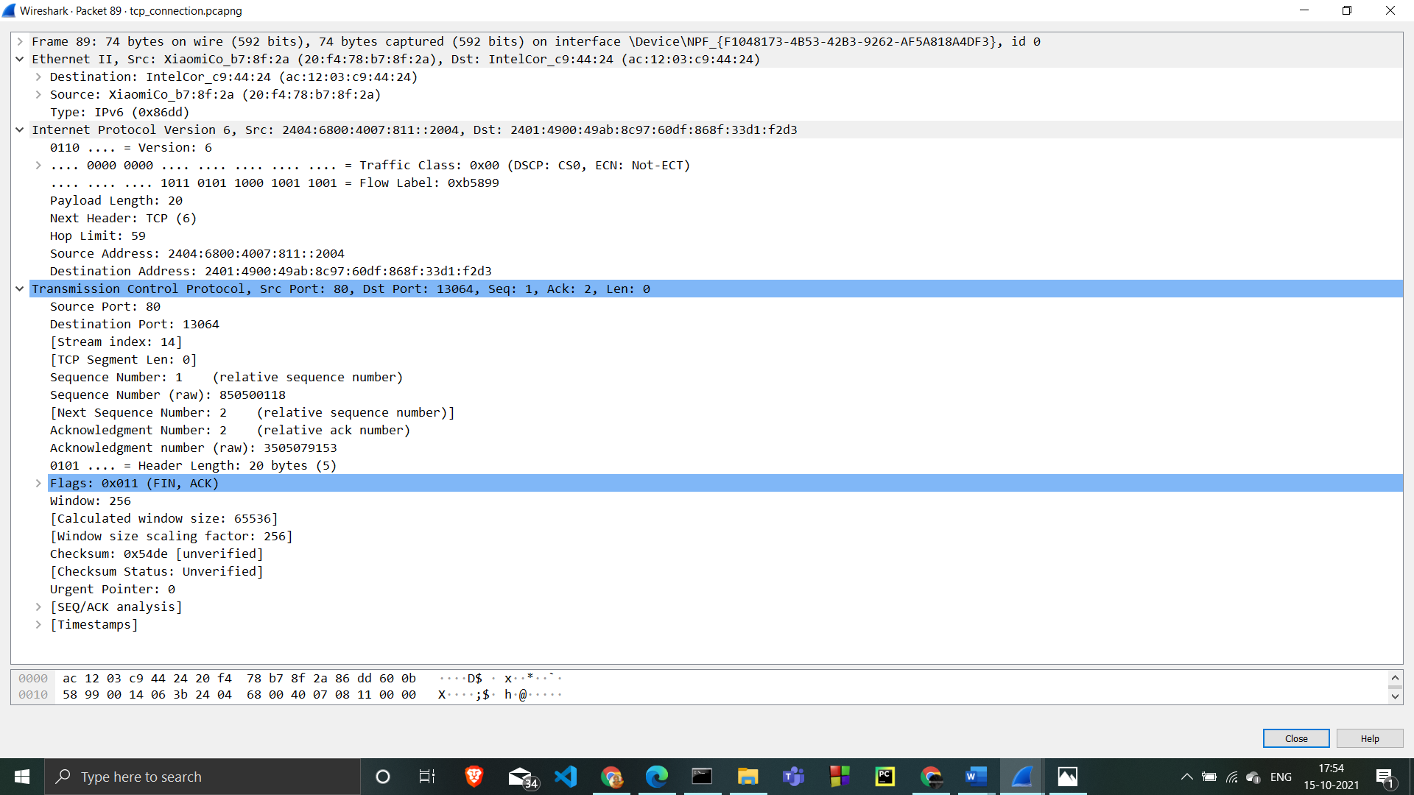

the Source port is http (80).

he same dynamic port selected for this connection

Sequence number is 1, Acknowledgement number is 2

Expand Flags

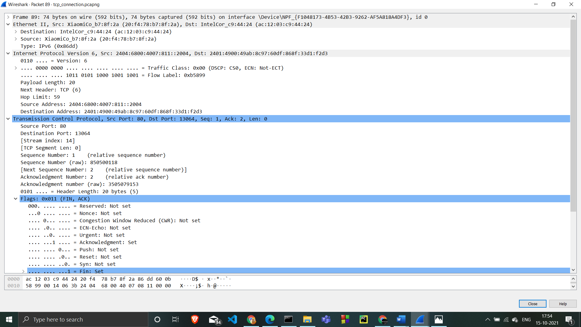

FIN and ACK are set

indicating the second segment in the TCP three-way handshake

The server has indicated it is closing the TCP connection with the client.

Analyse TCP ACK Traffic

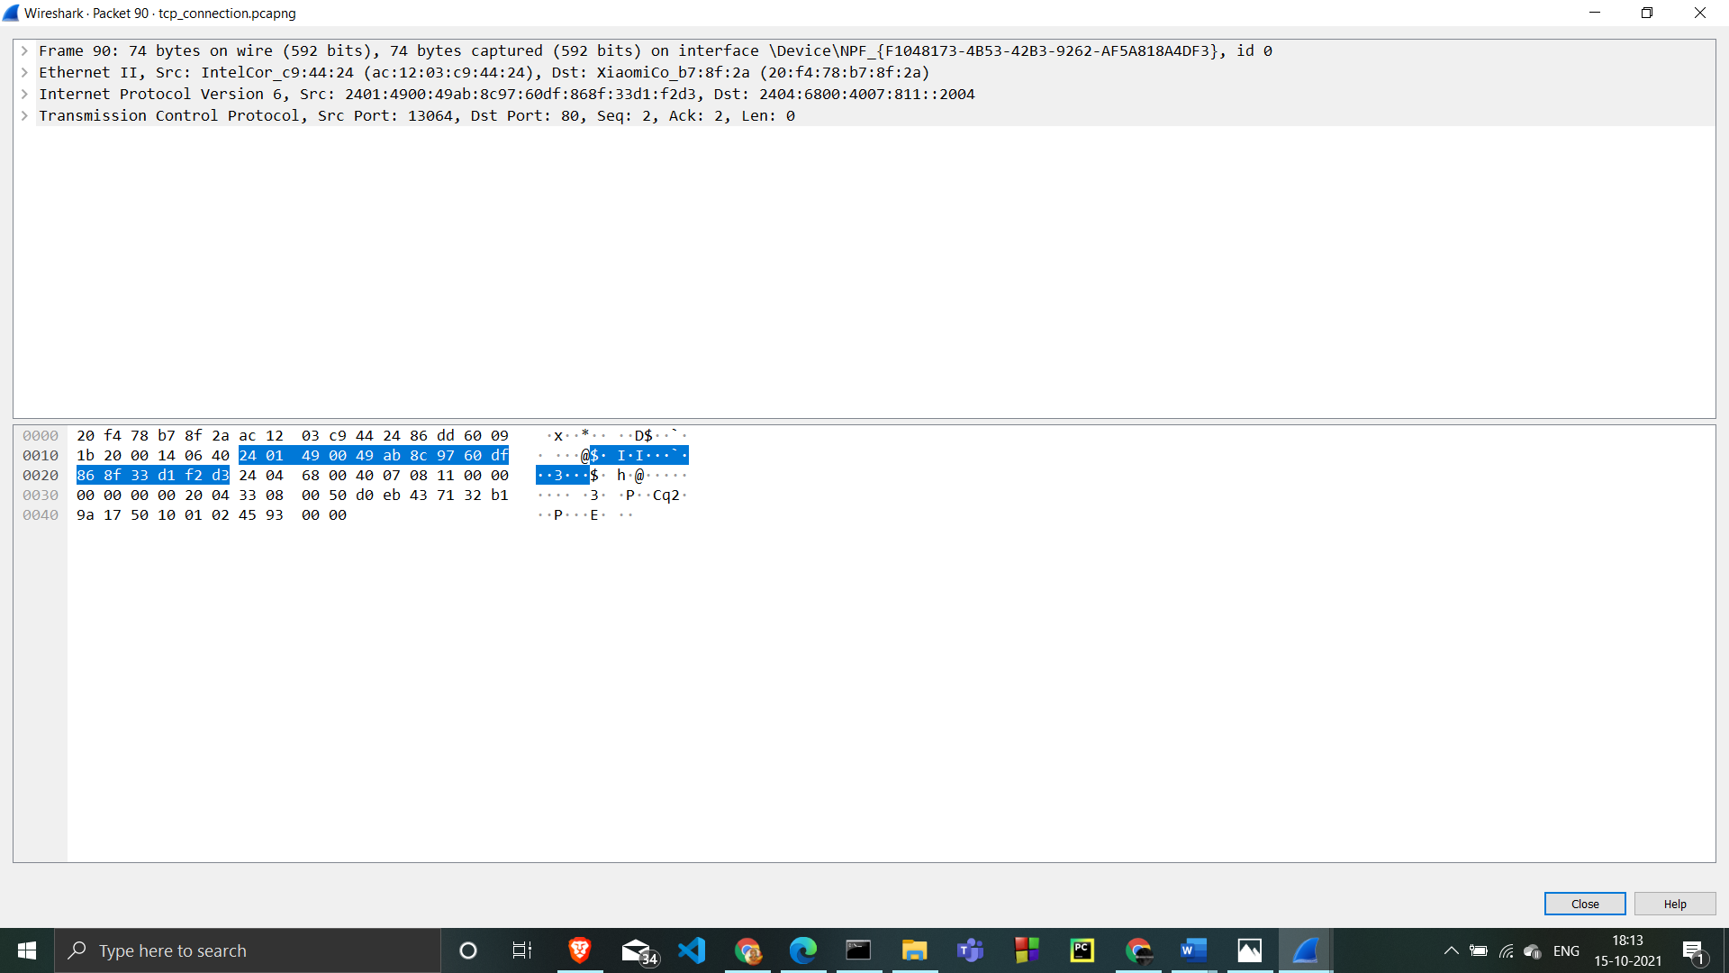

it is an Ethernet II / Internet Protocol Version 4 / Transmission Control Protocol frame.

Expand Ethernet II to view Ethernet details.

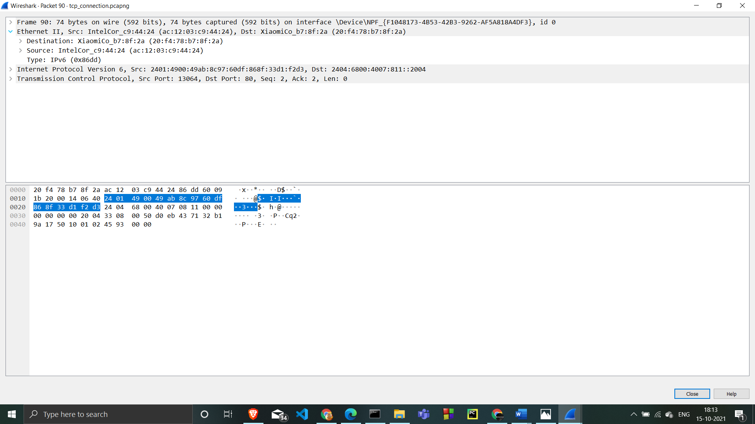

The destination system system default gateway MAC address

the source systeam MAC address.

Expand Internet Protocol Version 4 to view IP details

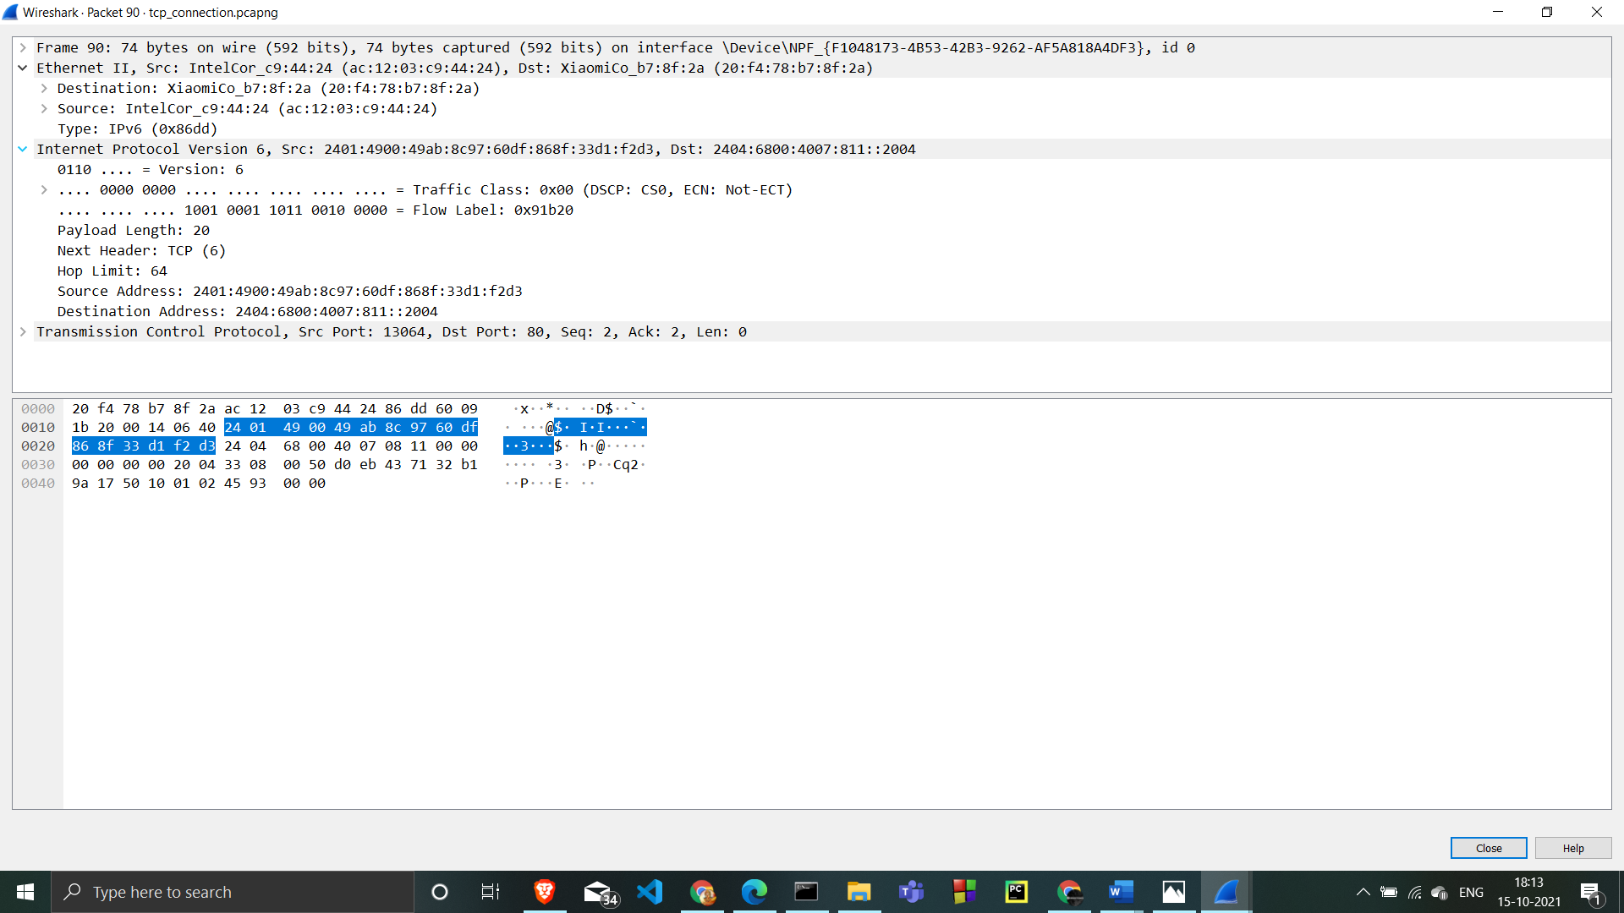

the source address is your IP address.

the destination address is the Google web server IP address

Expand Transmission Control Protocol to view TCP details.

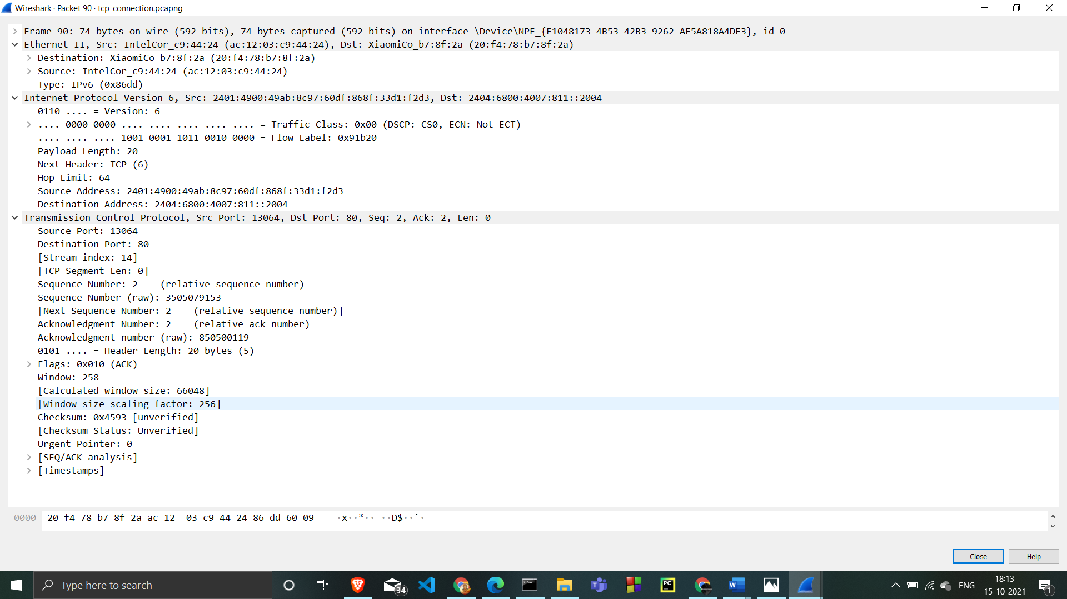

the Source port is the same dynamic port selected for this connection.

Destination port is http (80).

Sequence number is 2,  Acknowledgement number is 2

Expand Flags to view flag details.

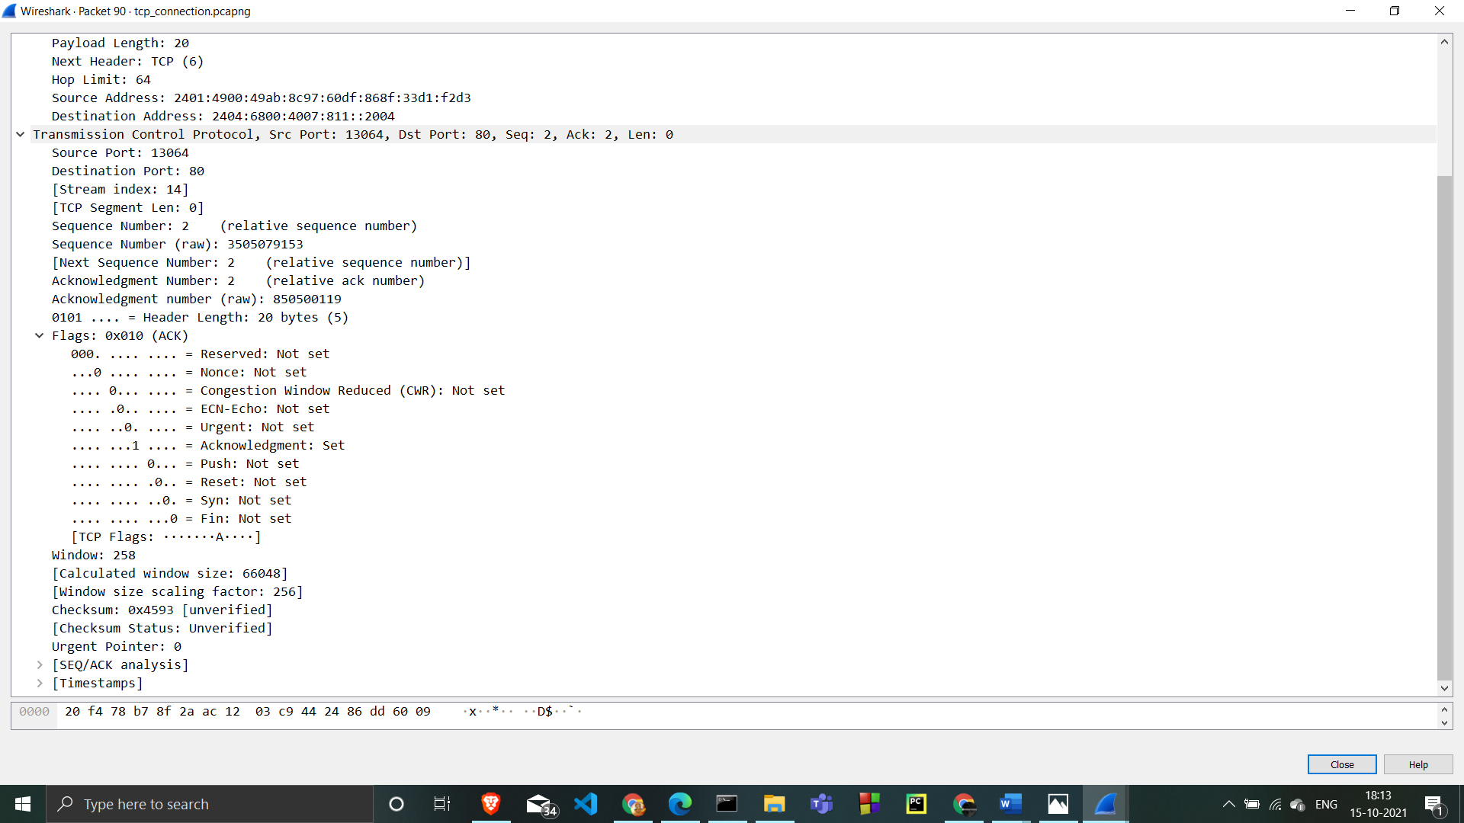

 ACK is set

indicating the third segment in the TCP teardown handshake

The client has acknowledged the server closing the TCP connection

**b. Identify if there are any retransmitted segments**

There are no retransmitted segments . We can verify this by checking the sequence numbers of the TCP segments in the trace file. In the Time-Sequence-Graph (Stevens) of this trace, all sequence numbers from the source to the destination are increasing monotonically with respect to time. If there is a retransmitted segment, the sequence number of this retransmitted segment should be smaller than those of its neighbours segments